PROJECT DEVELOPMENT - DELIVERY OF SPRINT 1

|  |  |
| --- | --- |
| Team ID: | PNT2022TMID03218 |
| Name: | Real-Time River Water Quality Monitoring and Control System |

**Coding for sprint 1:**

**Login.html**

<**html**>

<**head**>

<**meta** charset="UTF-8">

<**title**> Login </**title**>

<**link** rel="stylesheet" href="{{ url_for('static', filename='style.css') }}">

</**head**>

<**body**></**br**></**br**></**br**></**br**></**br**>

<**div** align="center">

<**div** align="center" class="border">

<**div** class="header">

<**h1** class="word">Login</**h1**>

</**div**></**br**></**br**></**br**>

<**h2** class="word">

<**form** action="{{ url_for('login') }}"

method="post">

<**div** class="msg">{{ msg }}</**div**>

<**input** id="username" name="username"

type="text" placeholder="Enter Your Username" class="textbox"/></**br**></**br**>

<**input** id="password" name="password" type="password" placeholder="Enter Your Password" class="textbox"/></**br**></**br**></**br**>

<**input** type="submit" class="btn" value="Sign

In"></**br**></**br**>

</**form**>

</**h2**>

<**p** class="bottom">Don't have an account? <**a** class="bottom" href="{{url_for('register')}}"> Sign Up here</**a**></**p**>

</**div**>

</**div**>

</**body**>

</**html**>

**Register.html**

<**html**>

<**head**>

<**meta** charset="UTF-8">

<**title**> Register </**title**>

<**link** rel="stylesheet" href="{{ url_for('static', filename='style.css') }}">

</**head**>

<**body**></**br**></**br**></**br**></**br**></**br**>

<**div** align="center">

<**div** align="center" class="border">

<**div** class="header">

<**h1** class="word">Register</**h1**>

</**div**></**br**></**br**></**br**>

<**h2** class="word">

<**form** action="{{ url_for('register') }}"

method="post">

<**div** class="msg">{{ msg }}</**div**>

<**input** id="username" name="username"

type="text" placeholder="Enter Your Username" class="textbox"/></**br**></**br**>

<**input** id="password" name="password" type="password" placeholder="Enter Your Password" class="textbox"/></**br**></**br**>

<**input** id="email" name="email" type="text" placeholder="Enter Your Email ID" class="textbox"/></**br**></**br**>

<**input** type="submit" class="btn" value="Sign

Up"></**br**>

</**form**>

</**h2**>

<**p** class="bottom">Already have an account? <**a**

class="bottom" href="{{url_for('login')}}"> Sign In here</**a**></**p**>

</**div**>

</**div**>

</**body**>

</**html**>

# Style.css

.header{

**padding**: 5px 120px; **width**: 150px; **height**: 70px;

**background-color**: #236B8E;

}

.border{

**padding**: 80px 50px; **width**: 400px; **height**: 450px;

**border**: 1px solid #236B8E; border-radius: 0px; **background-color**: #9AC0CD;

}

.btn {

**padding**: 10px 40px; **background-color**: #236B8E; **color**: #FFFFFF;

**font-style**: oblique; **font-weight**: bold; border-radius: 10px;

}

.textbox{

**padding**: 10px 40px; **background-color**: #236B8E; text-**color**: #FFFFFF; border-radius: 10px;

}

::placeholder { **color**: #FFFFFF; opacity: 1;

**font-style**: oblique;

**font-weight**: bold;

}

.word{

**color**: #FFFFFF;

**font-style**: oblique;

**font-weight**: bold;

}

.bottom{

**color**: #236B8E;

**font-style**: oblique;

**font-weight**: bold;

}

# Output: login page

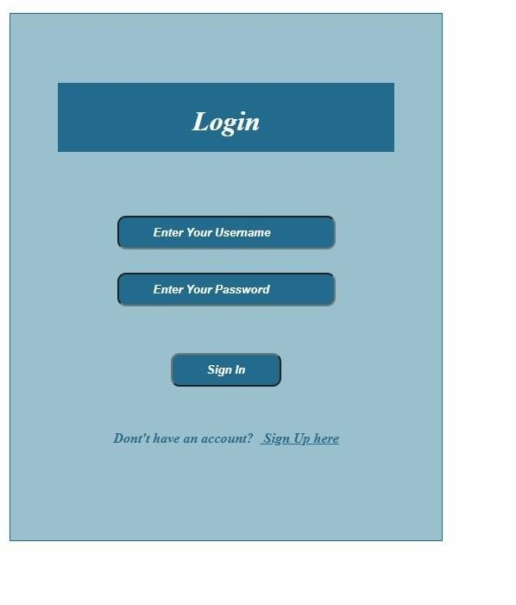

**Registration page:**

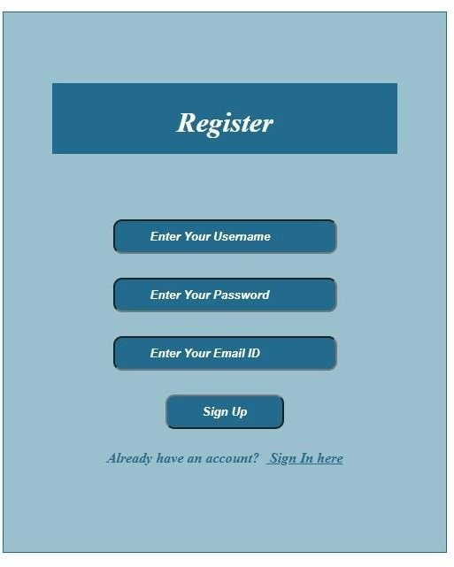

# Registration successful page:

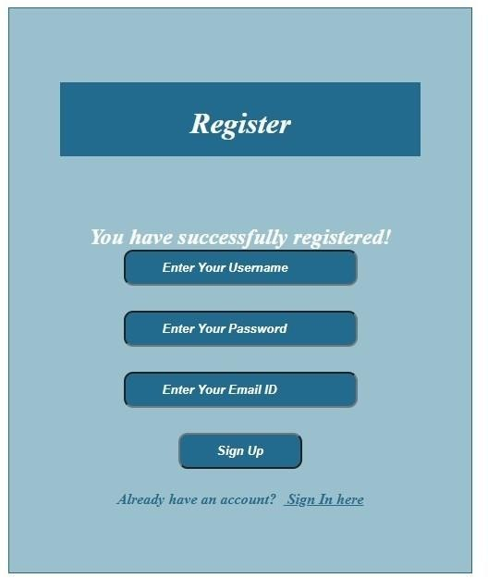

**Index page:**

